Vocabulary
Extraneous Solution:

Solving Basic Absolute Equations: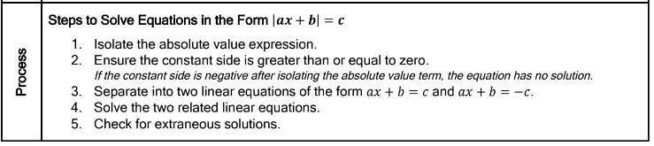
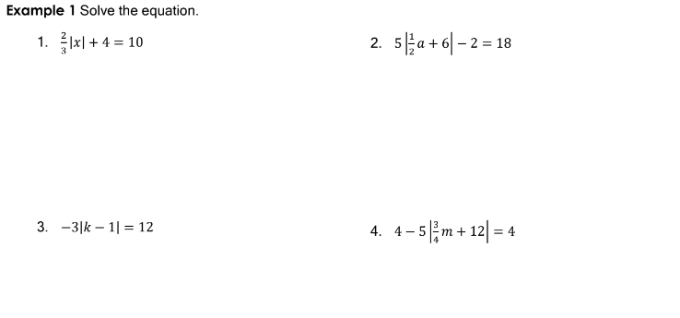

5. What is the sum of the solutions to the equation of: $\left|-6x-4\right|=22$

6. What is the sum of the solutions to the equation of: $\left|2x+4\right|=26$

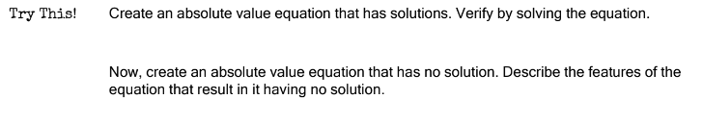

Solving Absolute Value Equations with variables on both sides:
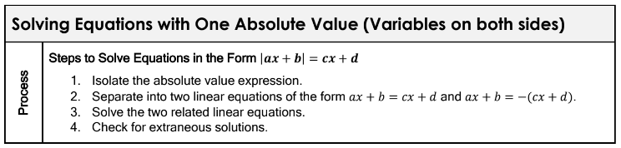
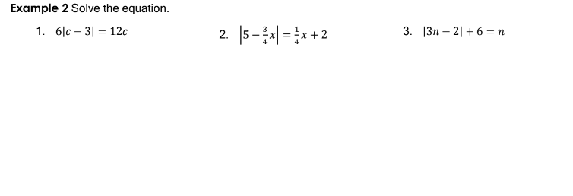

Solving Equations with Absolute Values on both sides:
